**CS-1001L**

**Programming Fundamentals**

**Project Title**

**Project Report By**

**Abrar Ul Abdin**

**Group Members:**

Abrar Ul Abdin cs191007

Table of Contents

1.Introduction 3

2.Scope 3

3.Flow Chart 3

4. C code 3

5. Hardware/Software Requirements 3

5.1 Tools 3

5.2 Libraries , IDE 3

6. Screen Shots 3

7. Task Sheet 3

# Introduction

# The main reason for designing a kitchen tutor program is to help a beginner cook as if he/she have no guide or active internet connection. He/she has to just enter any food dish from provided lists of 30+ recipes and he/she will get all details regarding that food dish such as ingredients, process, time period, etc.

# Scope

# The need that meets the user is if he/she is alone at home or any other place for a long period of time and is bored of getting food from hotels this program can easily help him to cook food by own.

# Flow Chart

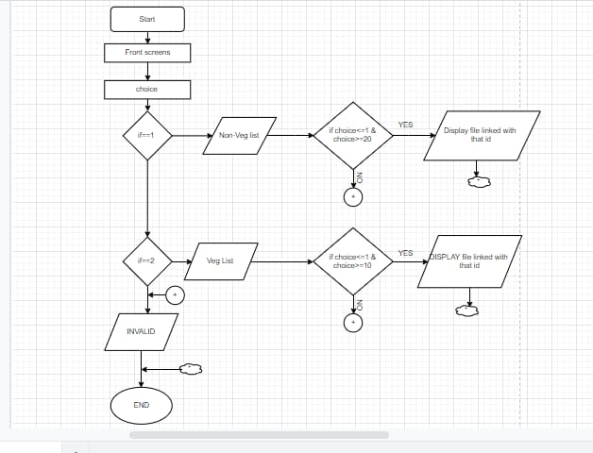

# 4. C Code

#include<stdio.h>

#include<conio.h>

#include<stdlib.h>

void frontheader()

{

printf("\n\n");

printf("\n * * * * * * * * * * * * ");

printf("\n ");

printf("\n * * ");

printf("\n HELLO ");

printf("\n * * ");

printf("\n ");

printf("\n * * * * * * * * * * * * ");

printf("\n\n");

printf("\nPress Any Key To Continue....");

}

void frontheader2()

{

printf("\n\n");

printf("\n ::::::::::::::::::::::::::::::::::::: ");

printf("\n :: :: ");

printf("\n :: :: ");

printf("\n :: I Am your Kitchen Assistant :: ");

printf("\n :: :: ");

printf("\n :: :: ");

printf("\n ::::::::::::::::::::::::::::::::::::: ");

printf("\n\n");

printf("\nPress Any Key To Continue....");

}

void frontheader3()

{

printf("\n\n");

printf("\n ::::::::::::::::::::::::::::::::::::: ");

printf("\n :: :: ");

printf("\n :: :: ");

printf("\n :: I Know Tasty Food Recipies :: ");

printf("\n :: :: ");

printf("\n :: :: ");

printf("\n ::::::::::::::::::::::::::::::::::::: ");

printf("\n\n");

printf("\nPress Any Key To Continue....");

}

int main()

{

frontheader();

getch();

system("CLS");

frontheader2();

getch();

system("CLS");

frontheader3();

getch();

system("CLS");

int type=0;

int foodchoice;

int foodchoicee;

printf("\n\n\n : : : : : : : : : : : : : : : : : : : : : : : : : ");

printf("\n\n FOOD TYPE ");

printf("\n\n - - - - - - - - - - - - - - - - - - - - - - - ");

printf("\n : Enter 1 for Non-Vegetarian Food : ");

printf("\n\n : Enter 2 for Vegetarian Food : ");

printf("\n - - - - - - - - - - - - - - - - - - - - - - - ");

printf("\n\n Your Choice : ");

scanf("%d",&type);

printf("\n : : : : : : : : : : : : : : : : : : : : : : : : : ");

printf("\n\n");

printf("\nPress Any Key To Continue....");

getch();

system("CLS");

if (type==1)

{

printf("\n\n\n");

printf("\n | SERIAL | FOOD | SERIAL | FOOD |");

printf("\n -------------------------------------------------------------- ");

printf("\n | | | | |");

printf("\n | 1 |Chicken roast | 11 |Nuggets sandwich |");

printf("\n | | | | |");

printf("\n | 2 |Beef marination | 12 |Kofta Chicken |");

printf("\n | | | | |");

printf("\n | 3 |Chicken Malai Boti | 13 |Kofta Biryani |");

printf("\n | | | | |");

printf("\n | 4 |Chicken malai kabab | 14 |Nargisi Kofta |");

printf("\n | | | | |");

printf("\n | 5 |Omellete keema roll | 15 |Macaroni Casserole |");

printf("\n | | | | |");

printf("\n | 6 |Pizza | 16 |Mutanjan with Beef |");

printf("\n | | | | |");

printf("\n | 7 |chicken changezi | 17 |Chicken Shashlik |");

printf("\n | | | | |");

printf("\n | 8 |Lemon Chicken | 18 |Chicken Manchurian |");

printf("\n | | | | |");

printf("\n | 9 |schezwan chicken | 19 |Beef Haleem |");

printf("\n | | | | |");

printf("\n | 10 |Dry Beef chili | 20 |Chicken Nihari |");

printf("\n | | | | |");

printf("\n --------------------------------------------------------------- ");

printf("\n\n\n");

printf(" Enter Your Choice (Serial) : ");

scanf("%d",&foodchoice);

printf("\nPress Any Key To Continue....");

getch();

system("CLS");

if (foodchoice==1)

{

FILE *fptr1;

char ch1;

fptr1 = fopen("chicken roast.txt","r");

while((ch1=getc(fptr1)) != EOF)

{

printf("%c", ch1);

}

}

else if (foodchoice==2)

{

FILE *fptr2;

char ch2;

fptr2 = fopen("beef marination.txt","r");

while((ch2=getc(fptr2)) != EOF)

{

printf("%c", ch2);

}

}

else if (foodchoice==3)

{

FILE *fptr3;

char ch3;

fptr3 = fopen("Chicken Malai Boti.txt","r");

while((ch3=getc(fptr3)) != EOF)

{

printf("%c", ch3);

}

}

else if (foodchoice==4)

{

FILE *fptr4;

char ch4;

fptr4 = fopen("chicken malai kabab.txt","r");

while((ch4=getc(fptr4)) != EOF)

{

printf("%c", ch4);

}

}

else if (foodchoice==5)

{

FILE *fptr5;

char ch5;

fptr5 = fopen("omellete keema roll.txt","r");

while((ch5=getc(fptr5)) != EOF)

{

printf("%c", ch5);

}

}

else if (foodchoice==6)

{

FILE *fptr6;

char ch6;

fptr6 = fopen("12 inch pizza.txt","r");

while((ch6=getc(fptr6)) != EOF)

{

printf("%c", ch6);

}

}

else if (foodchoice==7)

{

FILE *fptr7;

char ch7;

fptr7 = fopen("chicken changezi.txt","r");

while((ch7=getc(fptr7)) != EOF)

{

printf("%c", ch7);

}

}

else if (foodchoice==8)

{

FILE *fptr8;

char ch8;

fptr8 = fopen("Ingredients Lemon Chicken.txt","r");

while((ch8=getc(fptr8)) != EOF)

{

printf("%c", ch8);

}

}

else if (foodchoice==9)

{

FILE *fptr9;

char ch9;

fptr9 = fopen("Ingredients for schezwan chicken.txt","r");

while((ch9=getc(fptr9)) != EOF)

{

printf("%c", ch9);

}

}

else if (foodchoice==10)

{

FILE *fptr10;

char ch10;

fptr10 = fopen("Beef chili Dry.txt","r");

while((ch10=getc(fptr10)) != EOF)

{

printf("%c", ch10);

}

}

else if (foodchoice==11)

{

FILE *fptr11;

char ch11;

fptr11 = fopen("Ingredients for nuggets sandwich.txt","r");

while((ch11=getc(fptr11)) != EOF)

{

printf("%c", ch11);

}

}

else if (foodchoice==12)

{

FILE *fptr12;

char ch12;

fptr12 = fopen("Kofta Chicken.txt","r");

while((ch12=getc(fptr12)) != EOF)

{

printf("%c", ch12);

}

}else if (foodchoice==13)

{

FILE *fptr13;

char ch13;

fptr13 = fopen("Kofta Biryani Recipe.txt","r");

while((ch13=getc(fptr13)) != EOF)

{

printf("%c", ch13);

}

}else if (foodchoice==14)

{

FILE *fptr14;

char ch14;

fptr14 = fopen("Nargisi Kofta.txt","r");

while((ch14=getc(fptr14)) != EOF)

{

printf("%c", ch14);

}

}else if (foodchoice==15)

{

FILE *fptr15;

char ch15;

fptr15 = fopen("Macaroni Casserole.txt","r");

while((ch15=getc(fptr15)) != EOF)

{

printf("%c", ch15);

}

}

else if (foodchoice==16)

{

FILE *fptr16;

char ch16;

fptr16 = fopen("Mutanjan with Beef.txt","r");

while((ch16=getc(fptr16)) != EOF)

{

printf("%c", ch16);

}

}

else if (foodchoice==17)

{

FILE *fptr17;

char ch17;

fptr17 = fopen("Chicken Shashlik.txt","r");

while((ch17=getc(fptr17)) != EOF)

{

printf("%c", ch17);

}

}

else if (foodchoice==18)

{

FILE *fptr18;

char ch18;

fptr18 = fopen("Chicken Manchurian.txt","r");

while((ch18=getc(fptr18)) != EOF)

{

printf("%c", ch18);

}

}

else if (foodchoice==19)

{

FILE *fptr19;

char ch19;

fptr19 = fopen("Beef Haleem Recipe.txt","r");

while((ch19=getc(fptr19)) != EOF)

{

printf("%c", ch19);

}

}

else if (foodchoice==20)

{

FILE *fptr20;

char ch20;

fptr20 = fopen("Ingredients for Chicken Nihari.txt","r");

while((ch20=getc(fptr20)) != EOF)

{

printf("%c", ch20);

}

}

}

else if (type==2)

{

printf("\n\n\n");

printf("\n | SERIAL | FOOD | SERIAL | FOOD |");

printf("\n -------------------------------------------------------------- ");

printf("\n | | | | |");

printf("\n | 1 |Dhansak masala | 6 |Dal Chawal |");

printf("\n | | | | |");

printf("\n | 2 |Gobi Manchurian | 7 |Halwa Puri ChannA |");

printf("\n | | | | |");

printf("\n | 3 |Lahori Murgh Cholay | 8 |Tandoori Chai |");

printf("\n | | | | |");

printf("\n | 4 |TBSP Salt | 9 |Lacha Paratha |");

printf("\n | | | | |");

printf("\n | 5 |Fried WOnton | 10 |White Biryani |");

printf("\n | | | | |");

printf("\n --------------------------------------------------------------- ");

printf("\n\n\n");

printf(" Enter Your Choice (Serial) : ");

scanf("%d",&foodchoicee);

getch();

system("CLS");

printf("\nPress Any Key To Continue....");

if (foodchoicee==1)

{

FILE *fptrr1;

char cha1;

fptrr1 = fopen("dhansak masala.txt","r");

while((cha1=getc(fptrr1)) != EOF)

{

printf("%c", cha1);

}

}

else if (foodchoicee==2)

{

FILE *fptrr2;

char cha2;

fptrr2 = fopen("Gobi Manchurian.txt","r");

while((cha2=getc(fptrr2)) != EOF)

{

printf("%c", cha2);

}

}

else if (foodchoicee==3)

{

FILE *fptrr3;

char cha3;

fptrr3 = fopen("Lahori Murgh Cholay.txt","r");

while((cha3=getc(fptrr3)) != EOF)

{

printf("%c", cha3);

}

}

else if (foodchoicee==4)

{

FILE *fptrr4;

char cha4;

fptrr4 = fopen("Dal Chwal.txt","r");

while((cha4=getc(fptrr4)) != EOF)

{

printf("%c", cha4);

}

}

else if (foodchoicee==5)

{

FILE *fptrr5;

char cha5;

fptrr5 = fopen("Fried WOnton.txt","r");

while((cha5=getc(fptrr5)) != EOF)

{

printf("%c", cha5);

}

}

else if (foodchoicee==6)

{

FILE *fptrr6;

char cha6;

fptrr6 = fopen("Dal Chwal.txt","r");

while((cha6=getc(fptrr6)) != EOF)

{

printf("%c", cha6);

}

}

else if (foodchoicee==7)

{

FILE *fptrr7;

char cha7;

fptrr7 = fopen("Halwa Puri Channa.txt","r");

while((cha7=getc(fptrr7)) != EOF)

{

printf("%c", cha7);

}

}

else if (foodchoicee==8)

{

FILE *fptrr8;

char cha8;

fptrr8 = fopen("Tandoori Chaye.txt","r");

while((cha8=getc(fptrr8)) != EOF)

{

printf("%c", cha8);

}

}

else if (foodchoicee==9)

{

FILE *fptrr9;

char cha9;

fptrr9 = fopen("Lacha Paratha.txt","r");

while((cha9=getc(fptrr9)) != EOF)

{

printf("%c", cha9);

}

}

else if (foodchoicee==10)

{

FILE *fptrr10;

char cha10;

fptrr10 = fopen("White Biryani Recipe.txt","r");

while((cha10=getc(fptrr10)) != EOF)

{

printf("%c", cha10);

}

}

}

else

{

printf("Enter a valid type");

}

return 0;

}

# 5. Hardware/Software Requirements

## 5.1 Tools

## 5.2 Libraries , IDE

Libraries used in this project are the following:

Standard INPUT-OUTPUT

Standard Library

Con. INPUT-OUTPUT

# 6. Screen Shots

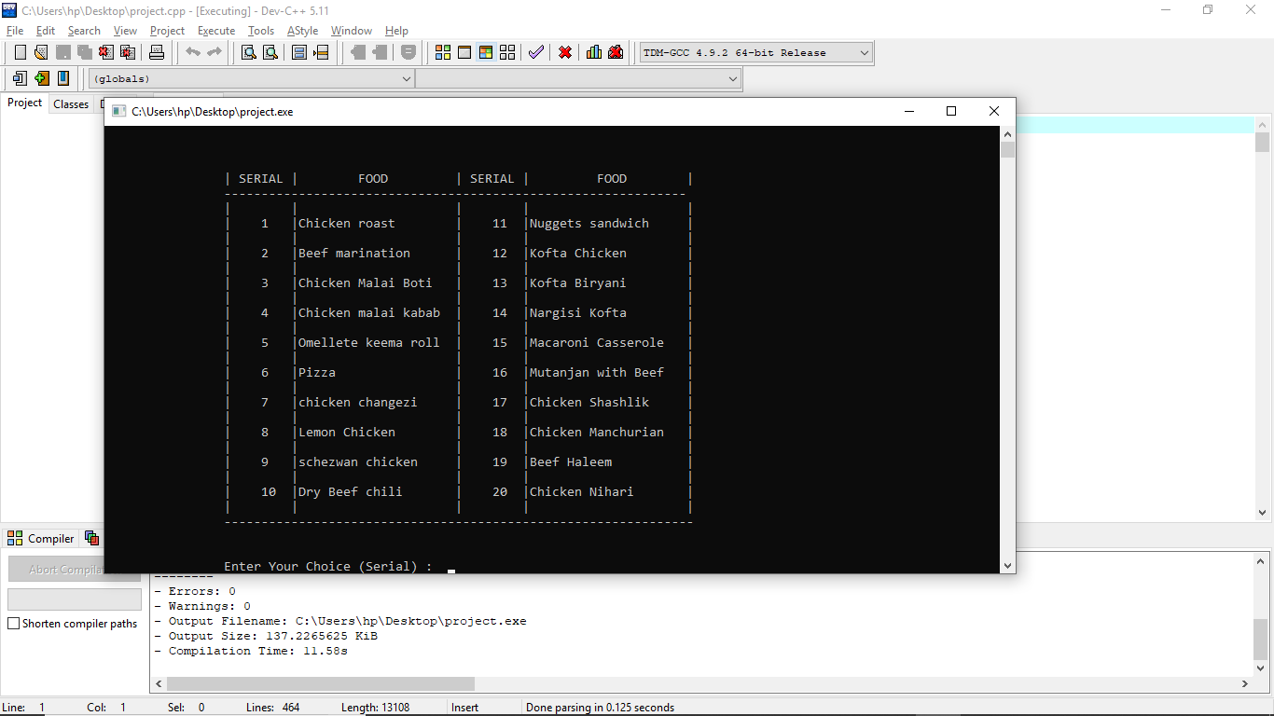

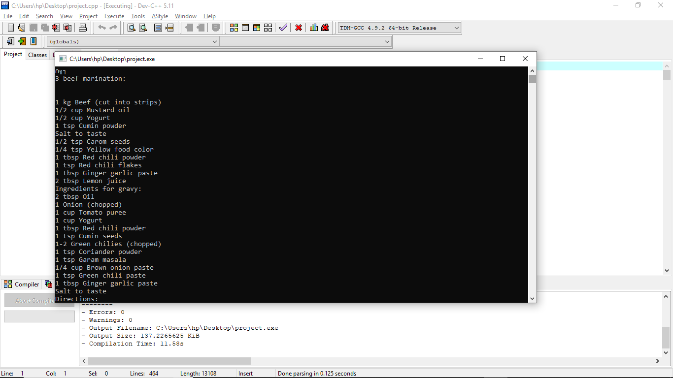

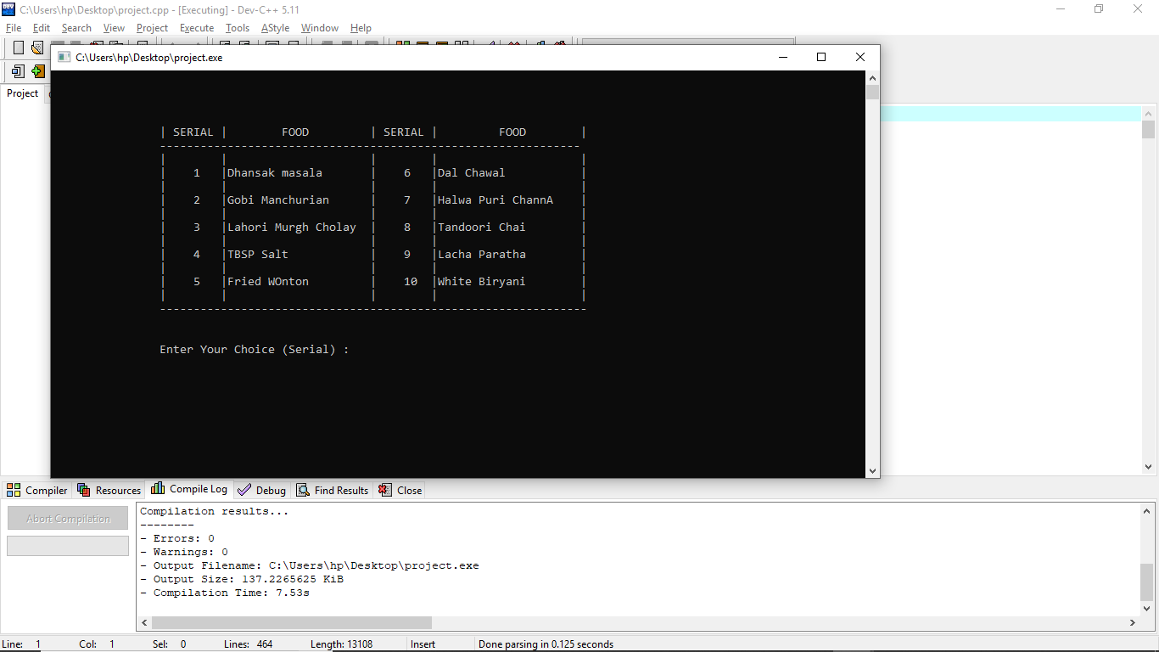

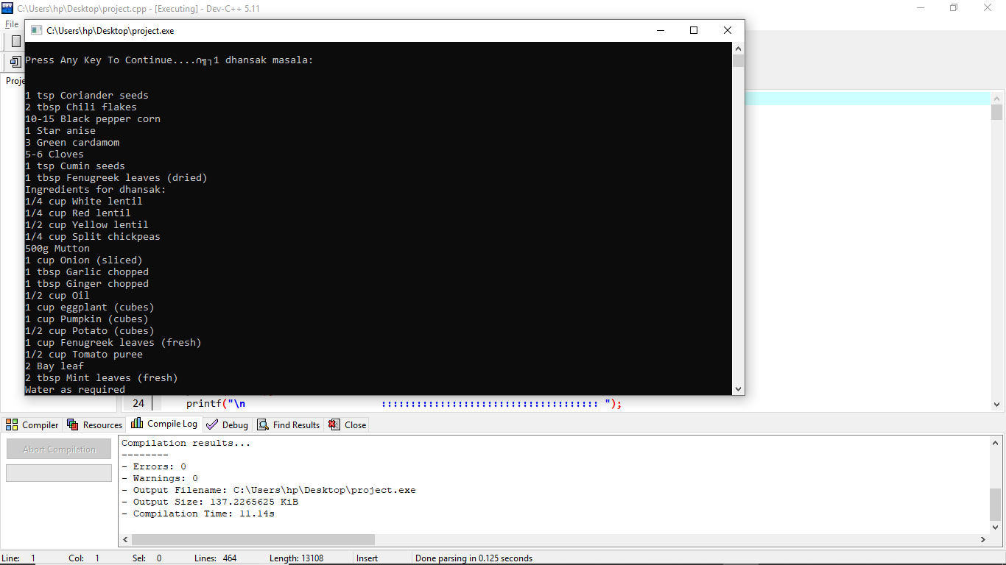

# 7. Code Screen Shots

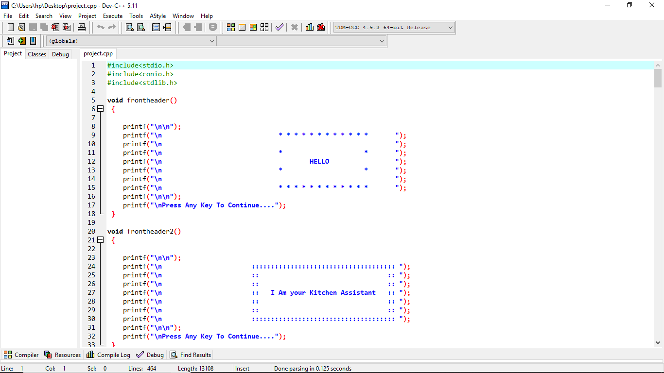

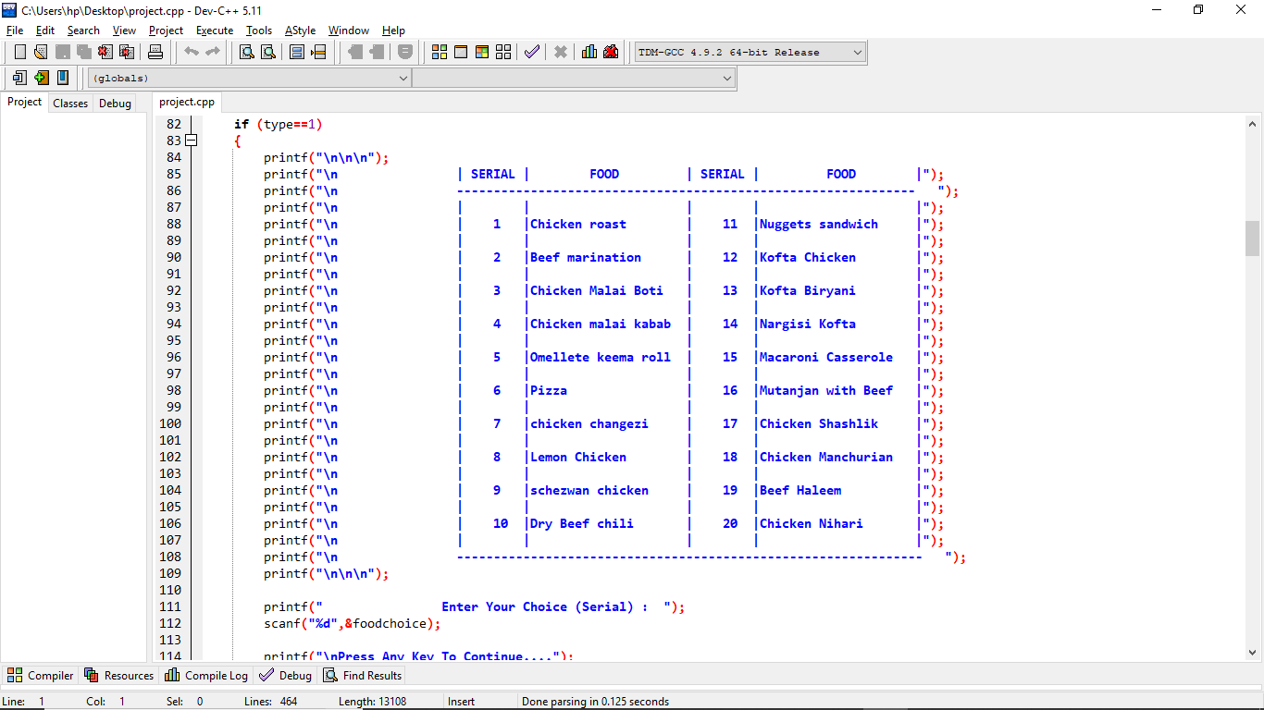

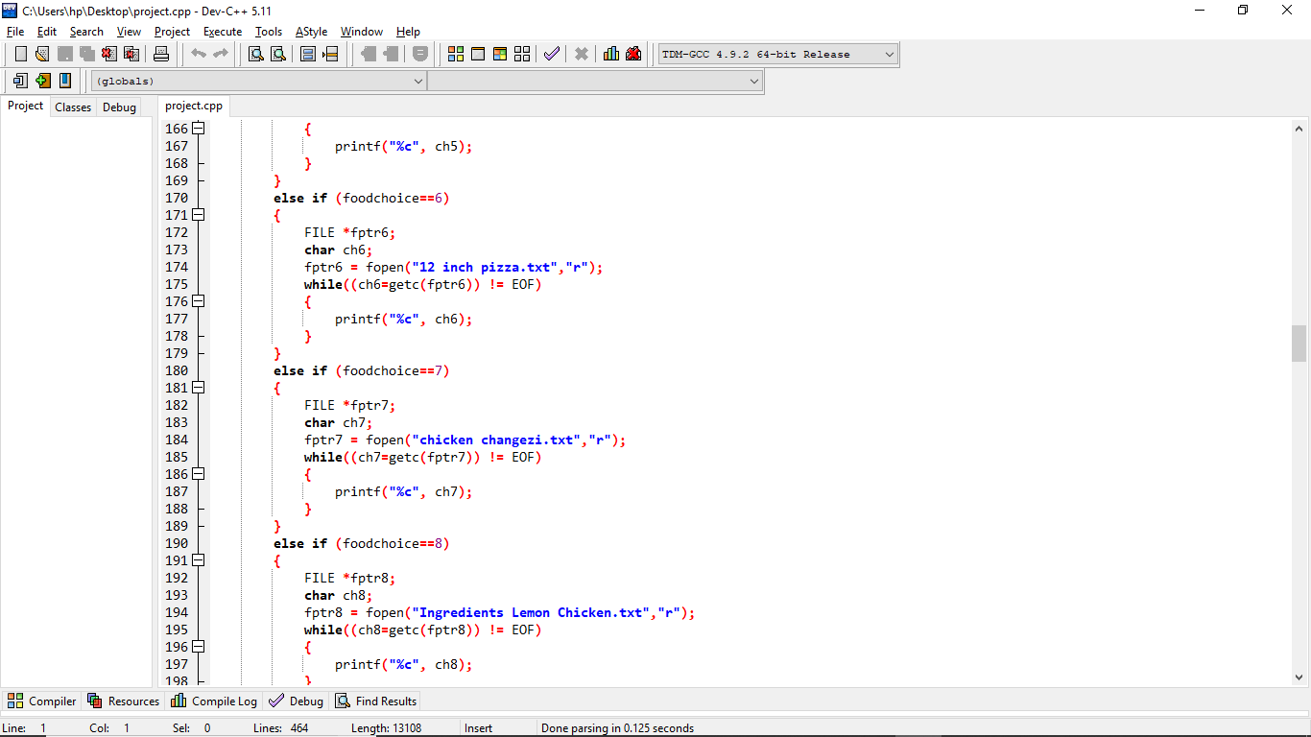

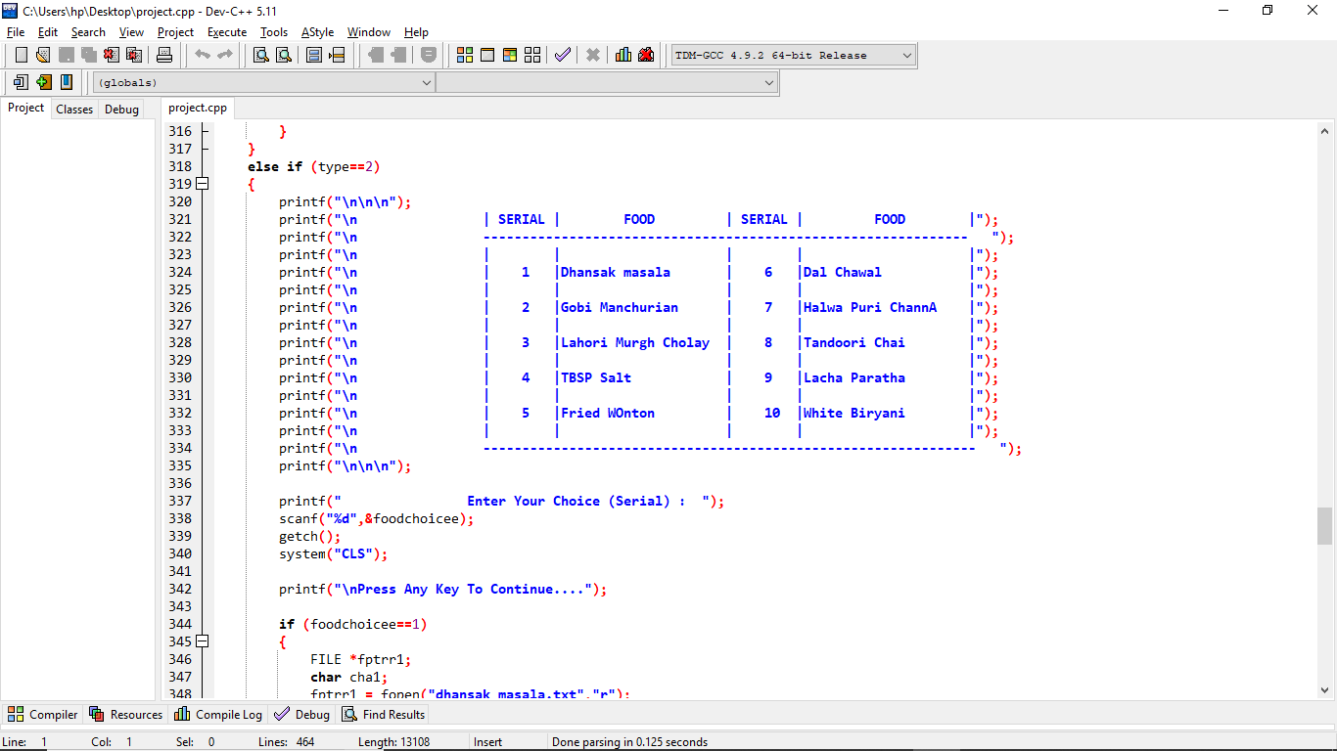

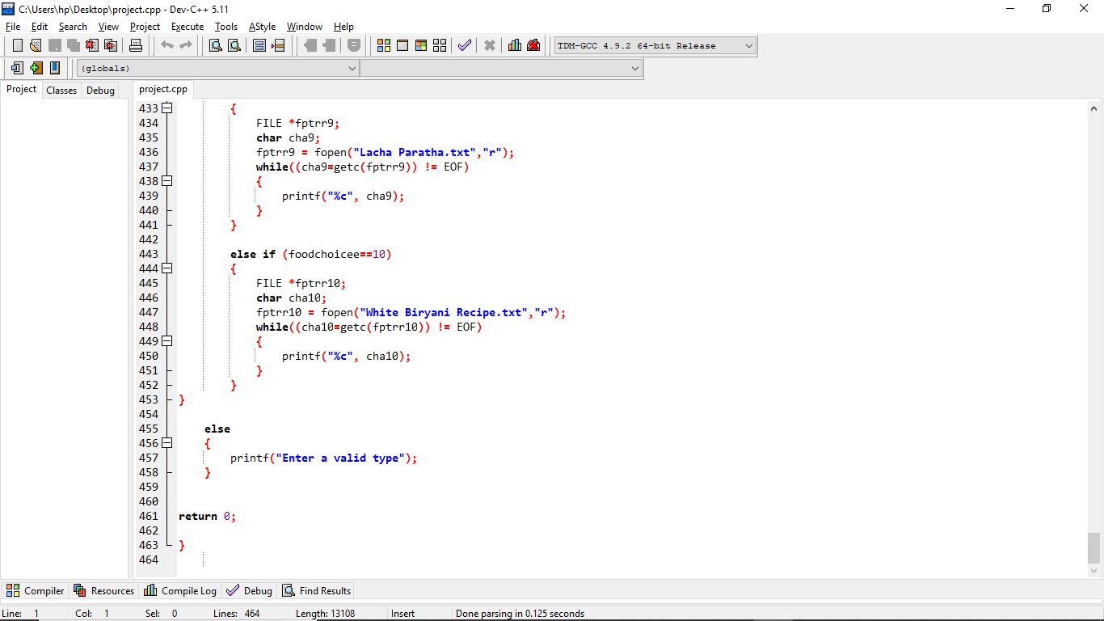

# 8. Gantt Chart / Task Sheet

